Lab: Hosting a Simple HTML Page with Apache Sever
You’ve built a web application and want users to access it. To make that happen, you need a web server to host it. One of the most popular options is the Apache HTTP Server. In this lab, we’ll host a simple HTML page using Apache.

Learning Objective
By the end, you will be able to:
- Install Apache on Ubuntu with apt.
- Control Apache using systemctl (start, stop, restart, status, enable at boot).
- Open the firewall for web traffic (port 80).
- Put an index.html file in the correct location and view it in a browser.

Pre-Requisite
- Ubuntu machine with sudo access (Use the one deployed in the first lab).
- Internet access (to download packages).
- A terminal (SSH or local).
- If on a cloud VM, ensure port 80 is allowed in security rules.
Tip: All commands below that change the system use sudo. Copy-paste is fine!

Steps to Follow

Part A — Update packages & install Apache
sudo apt update
sudo apt install -y apache2
- This installs Apache and creates a systemd service named apache2.
- Apache normally starts automatically after install.
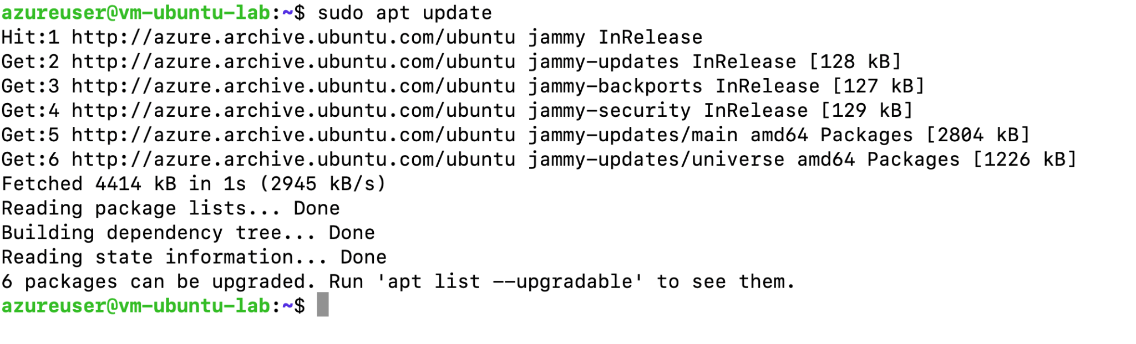
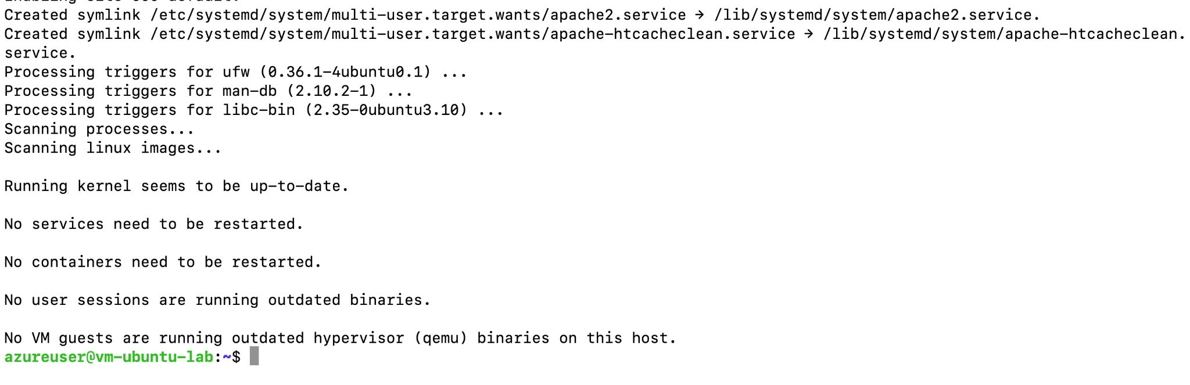

Part B — Manage Apache as a service
Check that Apache is running:
sudo systemctl status apache2

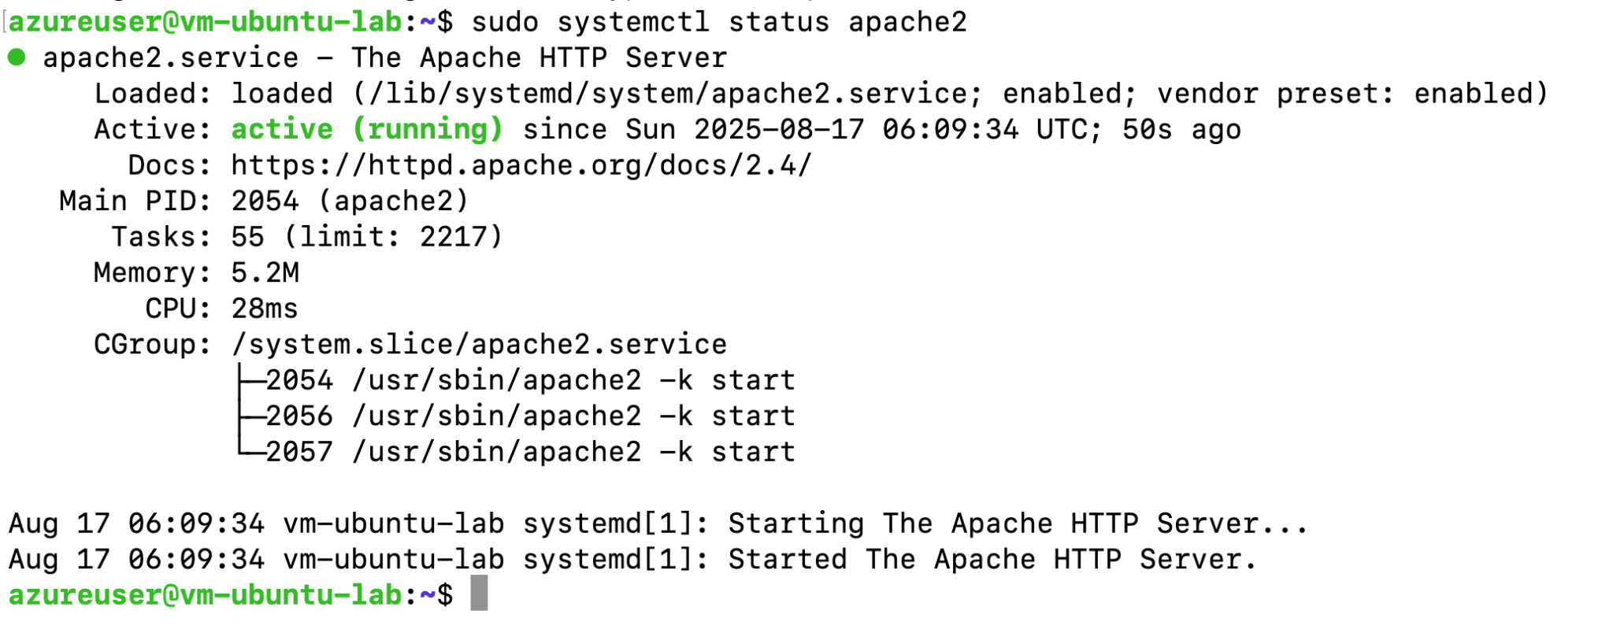
Note - Below is the list of other common actions you can perform with the apache server
sudo systemctl start apache2 # start if stopped
sudo systemctl stop apache2 # stop the server
sudo systemctl restart apache2 # restart (use after config/content changes)
sudo systemctl enable apache2 # start automatically on boot
sudo systemctl disable apache2 # don't start on boot

You can press q to exit the status view.

Part C — Open the firewall (in security rules)
By default Azure blocks all the incoming traffic. To enable traffic on any port like in this case we want traffic to come at port 80. We need to enable it through Azure cloud.
Follow the steps mentioned below.
- Login to Azure portal with your credentials.
- Navigate to virtual machine >> Your virtual machine
- Navigate to the Networking settings >> Add an Inbound Rule
- Add the rule to allow traffic at port 80.
- Follow the steps as shown in the screenshot below
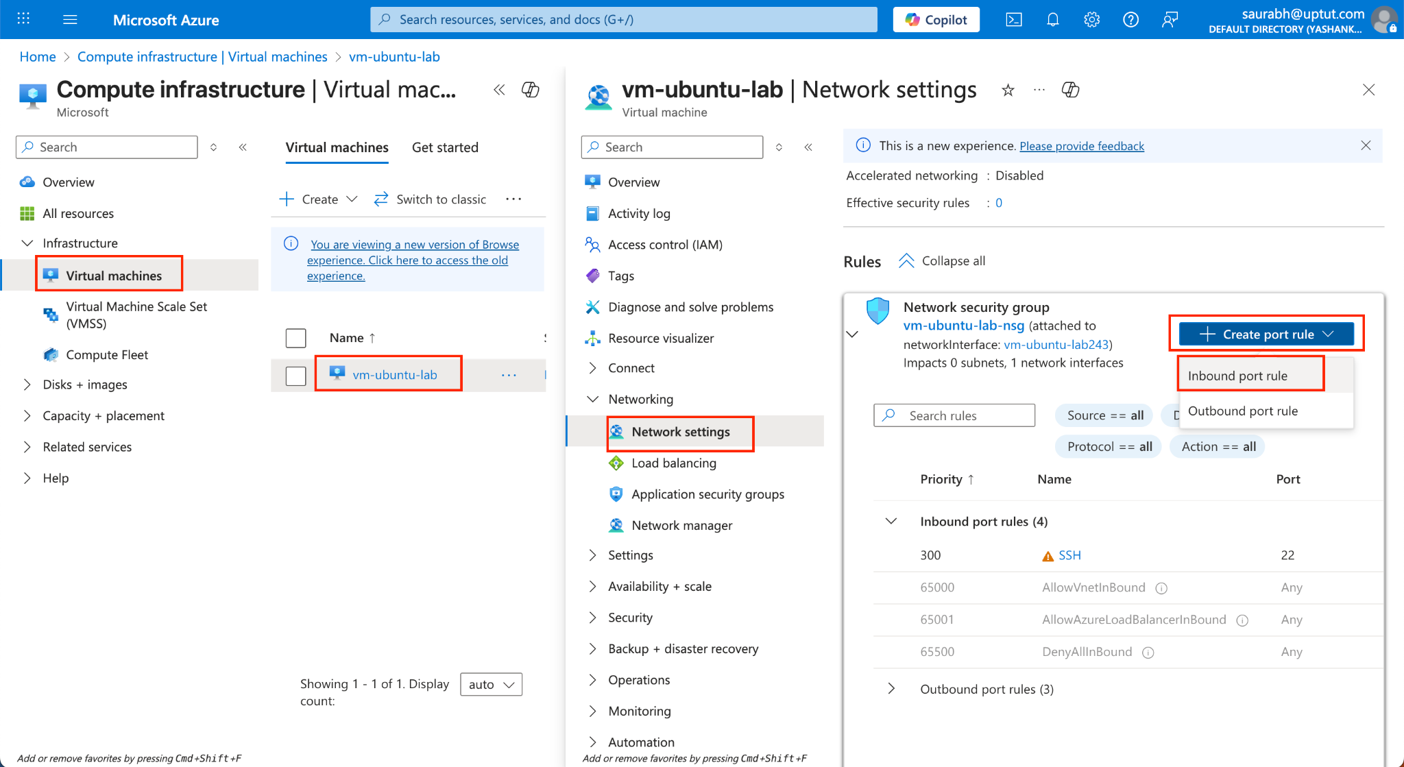
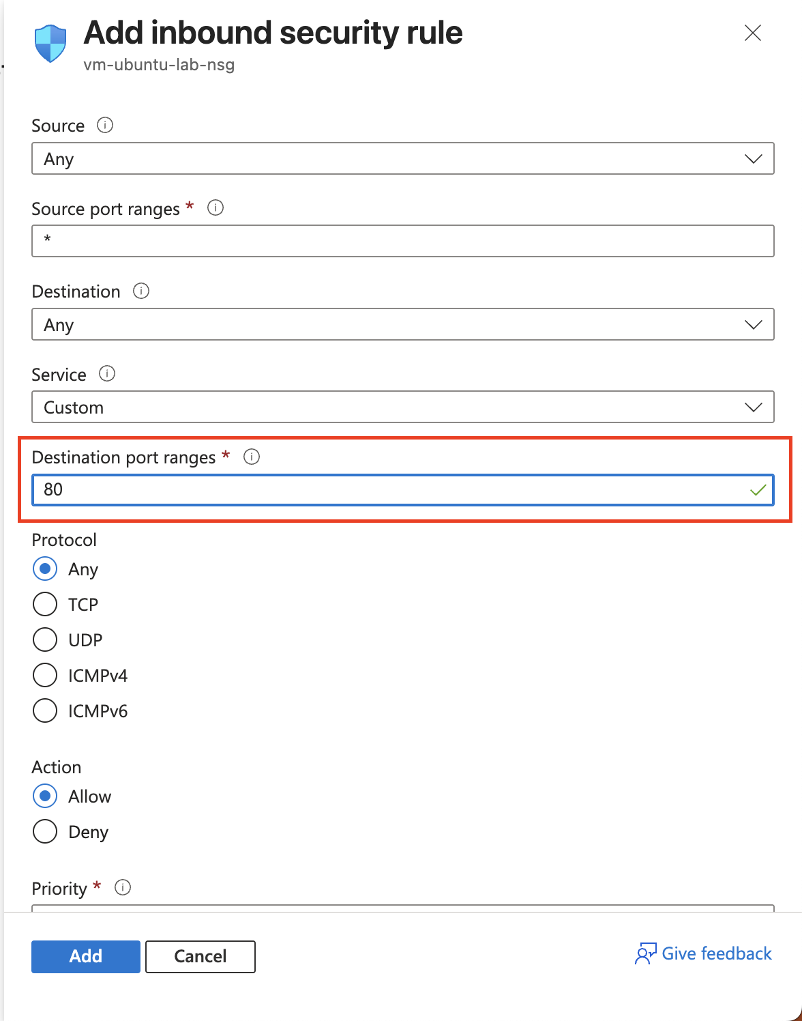

Part D — Create your simple HTML page
Apache’s default web root on Ubuntu is:
/var/www/html/

Replace the default page with your own:
echo '<!doctype html>
<html>
<head><meta charset="utf-8"><title>My First Apache Page</title></head>
<body style="font-family: sans-serif;">
<h1>Hello from Apache on Ubuntu!</h1>
<p>If you can read this, your web server works 🎉</p>
</body>
</html>' | sudo tee /var/www/html/index.html > /dev/null
(We use sudo tee because /var/www/html is root-owned.)

Part E — Test in your browser
In your browser, open:
http://<YOUR_SERVER_IP>/
You should see your Hello from Apache page.
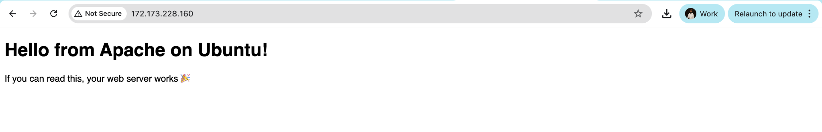
If it doesn’t load, re-check:
- Apache status: sudo systemctl status apache2
- Cloud security rules (port 80 open)

Part F — (Optional) Verify with curl (1–2 min)
From the server itself:
curl -I http://localhost/
curl http://localhost/

-I shows headers (you should see HTTP/1.1 200 OK).
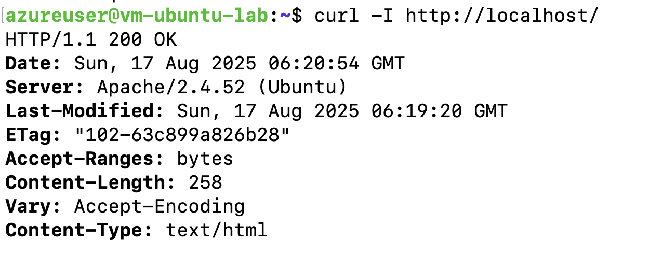
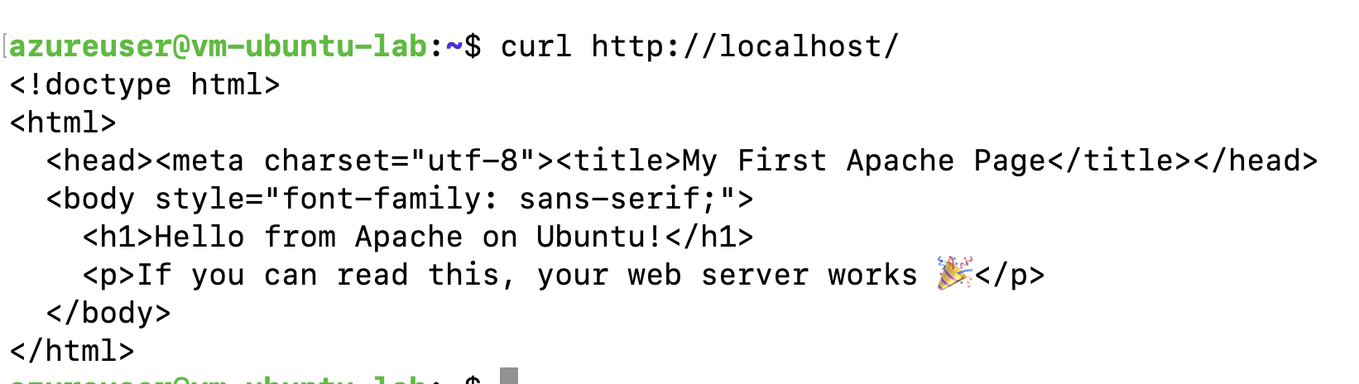

Part G — (Optional) Basic logs & where things live (2–3 min)
- Document root: /var/www/html/ (your index.html lives here)
- Main config directory: /etc/apache2/
  - Site configs: /etc/apache2/sites-available/ and sites-enabled/
- Logs: /var/log/apache2/ (access.log, error.log)
Check the error log if something fails:
sudo tail -n 50 /var/log/apache2/error.log

